Qibla.ly App

Fatima Mohamed

UMKC Student

Table of Contents
Vision Statement 4
Requirements 5
Step #1: Identify Categories of Users 5
Step #2: Create Actor-Goal List 5
Step #3: Identify User Stories 6
Product Backlog 7
[Step #4: Write Use Cases] 8
Sprint #1 12
Review 12
Retrospective 13
Design 14
Coding Standards 15

Vision Statement
For Muslims of all ages who want a simple app to maintain prayer times, Qibla.ly is a minimalist mobile app that does exactly that. Unlike traditional Islamic prayer apps, ours offer users a stress-free experience in order to facilitate a peaceful state of mind in preparation for their act of worship. Where traditional apps offer the chaos of an ad and feature cluttered Muslim hub, ours provides simplicity in style.

Requirements
- Categories of users:
  - Muslims who would like to be reminded of changing prayer times via their phones.
- Actor-Goal List:

Actor | Goal
App User | - Set location manually of automatically.  - Set preferred prayer call reciter.  - Find prayer direction (qibla) based on current location. (this involves using the phone as a compass)  - Set reminder intervals.  - Have ability to mute reminders.
- User Stories:
  - As a user of the Qibla.ly app, I want to receive notification of prayer times without the distractions of ads and superfluous features.
  - As a user of the Qibla.ly app, I want the option of choosing my call to prayer announcer so that I can have the most stress-free, relaxing experience. (Nobody wants the horrifying sound of someone screaming bloody murder to remind them that it’s time to pray)
  - As a user of the Qibla.ly app, I want to be able to easily find the prayer direction (qibla) without having to go through cumbersome steps.
  - As a user of the Qibla.ly app, I want the ability to set my reminder intervals so that I can choose how soon before prayer times I must get ready for the act.
  - As a user of the Qibla.ly app, I want the ability to mute some prayer calls, especially if I know I will need my phone on silent or vibrate. (Nobody wants the sound of an Arabic prayer call to interrupt a live play, for instance.)

- Product Backlog:

Story ID | Story | Story Points | Priority | Status
S1 | Allow user to choose between manually or automatically setting their location. | 15 | 1
S2 | Allow user to set their preferred prayer call reciter. | 5 | 3
S3 | Allow user to locate the prayer direction (qibla). | 13 | 2
S4 | Allow user to mute some prayer calls. | 2 | 4

Sprint #1
Before you can plan a sprint you need a prioritized list of user stories (the product backlog). Factors to consider when prioritizing stories include [Cohn, Agile Estimating and Planning]:
- Business value of feature
- Cost of implementation (story points or ideal days)
- Amount and value of new knowledge gained by developing the feature
- Risks resolved as a consequence of implementing the feature

Another important step in sprint planning is estimating project velocity. Project velocity is a measure of how much work is being completed each iteration (sprint). It is usually expressed using the same unit of measure used to estimate story effort (typically story points). For the first iteration, project velocity must be estimated based on past projects. After the first iteration, project velocity can be predicted based on the completed iterations.

The Sprint Backlog identifies stories planned for the sprint along with tasks necessary to complete each story.

Sprint Backlog
Story ID | Story / Task | Estimated  Hours | Actual  Hours
S1 | Update AndroidStudio libraries | 1 | 0.25
S2 | Design UI | 3 | 17
S3 | Determine external file format | 1 | 1
S4 | Write Usability test | 2 | 2
S5 | Write automated unit tests | 2 | 0
S6 | Research GEO/Location APIs | 7 | 0

Review
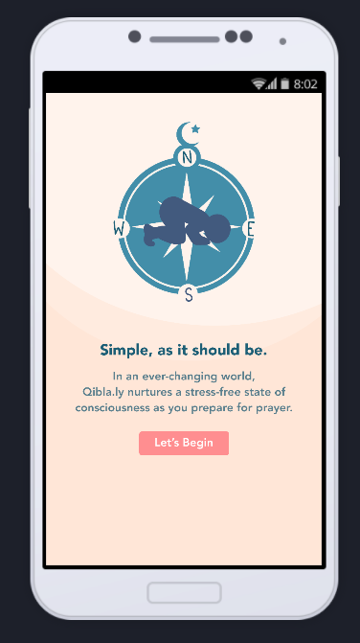
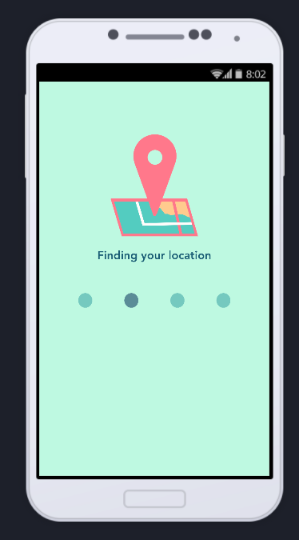
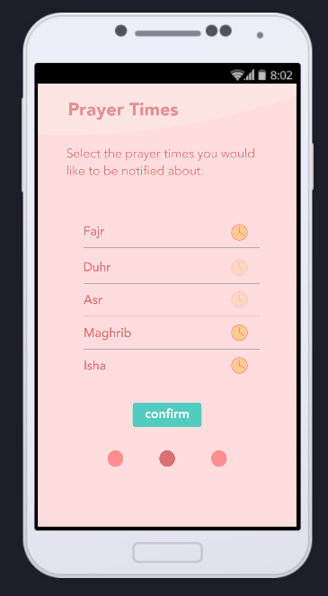
Screenshots:
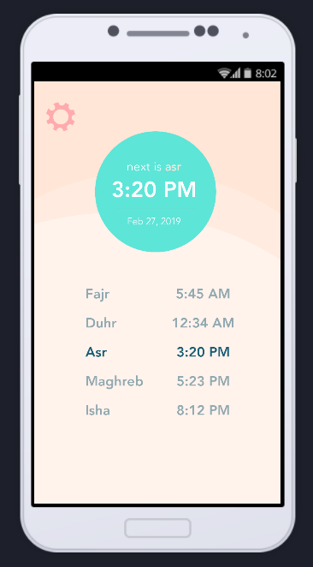

Source code:
Included on github.

Retrospective
This sprint helped me understand the reality of what I would be able to accomplish. What took the longest amount of time was learning the UX software so that I would not only be able to create an efficient wireframe, but a functional prototype as well. I decided to dedicate so much time to this because I wanted to conduct the usability testing on a functional prototype, and this would not have worked if I hadn’t spent time understanding the software. I didn’t get as much coding as I would have liked to, and there were items on my list to accomplish that I hadn’t even had a chance to glance at due to overestimating what I could accomplish. This experience will come in handy for planning Sprint #2.

Project Velocity: 15
I planned to complete 6 stories but was only able to do 3, which combined for a total of 12 story points. Now that I have a good understanding on what I need to do next, I will be able to adjust accordingly to what I need to do in the next Sprint. I have a better idea on how to handle learning curves, my time as well as my energy to uphold efficiency in my process.

Sprint #2
Sprint Backlog
Story ID | Story / Task | Estimated  Hours | Actual  Hours
S5 | Write automated unit tests | 2
S6 | Research GEO/Location APIs | 7
S7 | Program functionality of 4 main pages | 20
S8 | Carry out usability testing on prototype | 6

- User Stories:
  - As an admin of Qibla.ly, I want to know what users think of the app.
  - As a user of Qibla.ly, I want to be able to use my location to import prayer times.
  - As an admin of Qibla.ly, I want to a functional app with only necessary functions.
  - As an admin of Qibla.ly, I want to ensure that I can catch future bugs in code.

Additional Constraints, Comments, etc.
- The system shall:
  - Include theme options for the user to choose from. They will come in 3 varying, simple colors similar to the Microsoft Office theme options.
  - Have a layout similar to the Apple weather app for simplicity.
  - Have a opt-in encouragement reminders daily. This will include religious quotes, etc.
  - Have a special opt-in option for those who find it hard to wake up in the morning for the dawn prayer (usually between 4-5am)

